LR_1

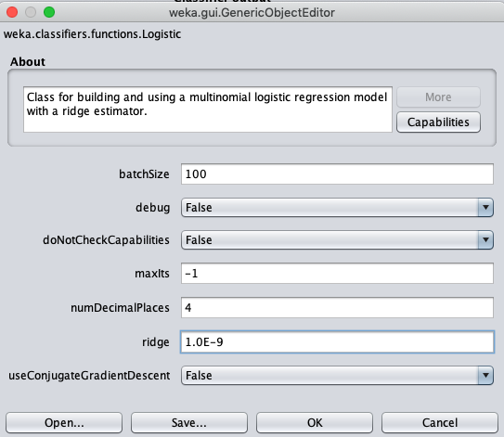



LR_2

16 features. Marketing feature was deleted

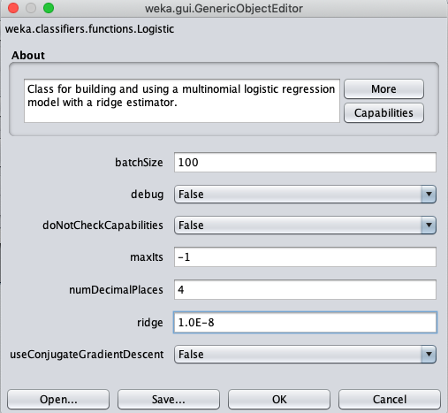



LR_3

15 features. Marketing feature was deleted

